**BLCC Edits – 3-21-2024**

**I have provided most comments page by page.**

**I included a screenshot so you know the version of the interface I am looking at.**

**Landing Page**

Add a link to E3 to “Powered by E3”

Condense the text boxes vertically to get rid of blank space.

Change 3rd paragraph to:

Through support from the Department of Energy (DOE) Federal Energy Management Program (FEMP), the National Institute of Standards and Technology (NIST) developed life cycle cost analysis support resources to provide computational support for the analysis of capital investments in buildings, including:

* Building Life Cycle Cost (BLCC)
* Energy Escalation Rate Calculator (EERC) [hyperlink: <https://pages.nist.gov/eerc/>]
* Handbook 135 [hyperlink: <https://doi.org/10.6028/NIST.HB.135e2022-upd1>]
* Annual Supplement to Handbook 135 [hyperlink: <https://doi.org/10.6028/NIST.IR.85-3273-39>]
* Data Tables for Annual Supplement [hyperlink: <https://doi.org/10.18434/mds2-3194>]

All these resources can be found at the DOE FEMP for their BLCC Program Page: <https://www.energy.gov/femp/building-life-cycle-cost-programs>.

**General Comments on Design of Editor**

Whichever left hand tab you are on should be identified/highlighted.

Whenever you have the time, we will need to add information icons to EVERYTHING [low priority]

Selecting New or Open should include a popup asking whether they want to save the existing project

If yes, then save and if no, delete. Then continue to the respective action (new or open)

Opening an existing project

Need to provide a notification that uploading an existing file will not automatically check whether current federal discounting assumption requirements are met. Reselecting the Analysis Type will automatically update these values.

Opening Financed Project

It does not appear to open the contract objects from the original file

Use FedFinanced example to test

If required inputs are not provided

Highlight the missing field somehow (red box/text) on page

Provide warning message in the footer (X # errors)

If errors exist and the user tries to run results

Popup notifying user of the current list of errors and where to find them (can you direct them to the page for each?

**Page – General Information**

Rename “Length of Study Period” to “Study Period”

Remove defaults for:

Analysis Type [this forces them to make the selection and the discount rates, inflation rate, dollar analysis, and discounting convention should update accordingly. Note Analysis Purpose is also needed for OMB-Non-energy]

Study Period

Discounting convention

Discount related things all auto-populate with analysis type selection – See red box. [I may need to provide with these mappings still]

Need a spot check to confirm consistency in discount rates

If constant, need real discount rate

Note: Josh needs to check on a scenario where a user adds a current dollar cost object (main issue is contract recurring payments), then how is that handled? I think BLCC currently has the user input a “deflator” value)

If current, need inflation and nominal rate

Do not allow user to input both real and nominal+inflation values. Only one or the other.

If the analysis type has already been selected, then you need to add popups for the following changes:

If the analysis type is switched, popup to confirm they want to make the change and inform them the discounting related assumptions will automatically update.

If any of the auto-populated values are modified, you need to create a popup that asks them to confirm the change because the change is not consistent with the federal requirements for that analysis type.

[I can help with final wording on these]

Required Fields should have a *:

Project Name, Analysis Type, Study Period, Construction Period, Data Release Year, discount rates, inflation rate, dollar analysis, and discounting convention, ZIP, emissions rate scenario, Social Cost of GHG Scenario

Change “MILCON Analysis, ECIP Project” to “MILCON Analysis, ERCIP (formerly ECIP) Project”

Round %s to 2 decimal places

Study Period should be an integer and cannot be longer than 40 + Construction Period

Construction period should be integer (range of 0-3)

ZIP should be 5 digits only (no decimals or letters)

Question: Can we provide a guided search for the user to find a zip code in the selected state?

If MILCON Analysis, ECIP Project selected as the project type:

we need a unique capital cost page [that I still need to provide you]

all cost objects EXCEPT the capital and contract will default to cost savings in the cost pages

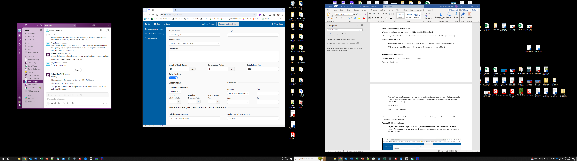

**Page – Alternative Summary**

Add Alternative

In popup, change “Name” to “Alternative Name”

Validation Issue – Need to make sure you cannot add alternative with the same name that already exists

Identifying/Selecting Base Case

I like the “B” to identify the base case, but it would be beneficial to be able to quickly switch the base case on this page. It could be a selection box that is filled with the “B” when selected.

Note this would also require a popup to confirm the user wants to change their base case.

Question: Could we have a “Clone Alternative” option? Or would that be too complicated. I could see someone wanting to tweak an existing alternative a little or to run sensitivity analysis that way.

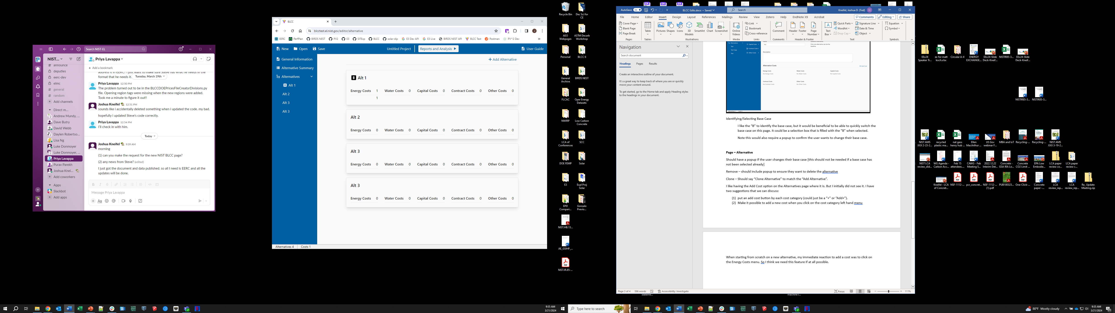

B

**Page – Alternative**

Should have a popup if the user changes their base case [this should not be needed if a base case has not been selected already]

Remove – should include popup to ensure they want to delete the alternative

Clone – Should say “Clone Alternative” to match the “Add Alternative”.

I like having the Add Cost option on the Alternatives page where it is. But I initially did not see it. I have two suggestions that we can discuss:

1. put an add cost button by each cost category (could just be a “+” or “+Add” to the right of the category title [red square area] or at the bottom of the list [red rectangle])
2. Make it possible to add a new cost when you click on the cost category left hand menu [orange rectangle area]

Note: The difference between this and the current Add Cost is that it will default the cost category in the popup. This would require knowing both the category and sub-category of the cost. So we probably need the subcategories to show up even when no costs are in the category.

When starting from scratch on a new alternative, my immediate reaction to add a cost was to click on the Energy Costs menu. So I think we need this feature if at all possible.

Change sub-category names for Capital Costs

Capital to Investment

Replacement Capital to Replacement

Add sub-categories for Other

Other Monetary

Other Non-Monetary

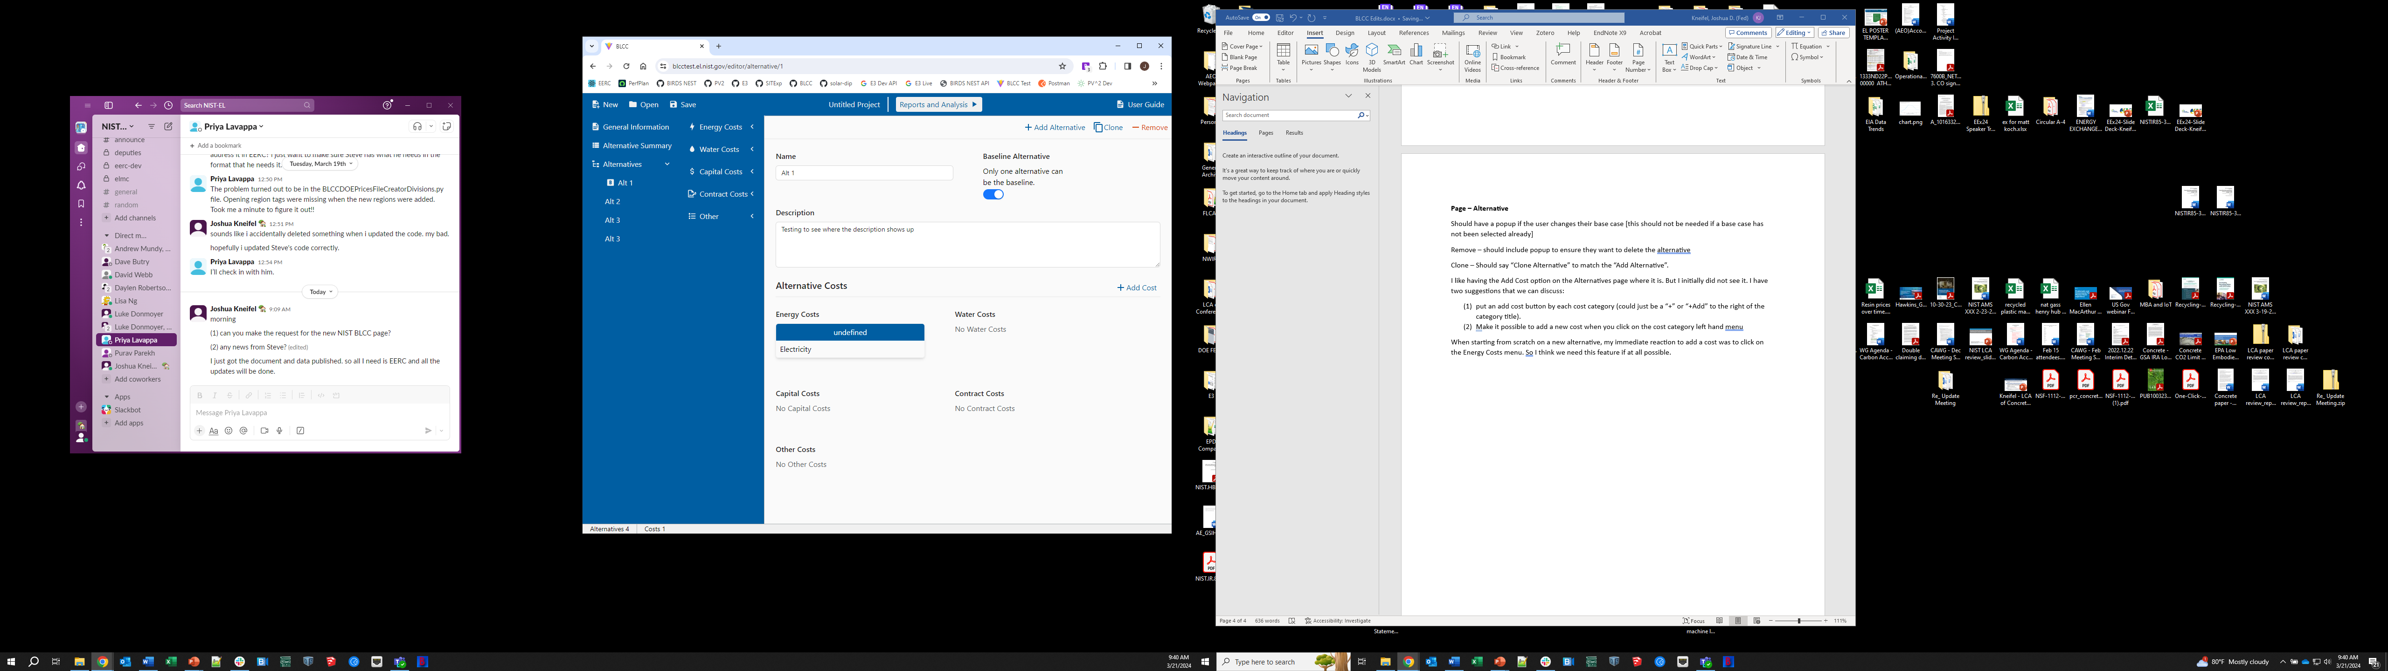

**Page – Cost (General Comments)**

Cost or Savings button

Should be able to read “Cost”. Right now you can only read “Savings” when selected (see current vs constant dollar toggle on General Information page)

If savings is selected, then anything below that selection that current says “Cost” should be dynamic and update to “Cost Savings”. I will try to identify those on the individual page comments below.

Make Recurring “No” Visible (similar issue to previous)

Water does not work right now, correct? It crashes everything when I add it. I assume the same will happen with Other

Expected Lifetime should only be whole integers

Any dollar input should be limited to 2 decimals

Any percentage should be limited to +/- 100 %

All values are required except description [I will try to look for exceptions to this, but I think it holds]

All “Initial Cost” should include “(Base Year Dollars)”

We should walk through how the cost adjustment factor and annual rate of increase will impact the resulting E3 objects to make sure they are being calculated correctly

**Page – Capital Cost – Investment**

Annual Rate of Change

Add “(for residual value calculation)” under the heading

Cost Adjustment Factor

Add “(for phased-in investments)” under the heading

Move CAF to left hand side under Expected Lifetime

Create a new section of the page with an overarching heading: “Cost-Phasing of Initial Cost”

Delete one of the tables at the bottom

Delete the Constant/Non-Constant toggles

For the remaining table

Size of the table is based on the construction period (0-3 years)

Default to 100% in Year 0

Check that %s add up to 100%

If amount financed >0

Should check when run requested to confirm that a contract object exists

If savings selected in toggle

Initial Cost -> Initial Cost Savings

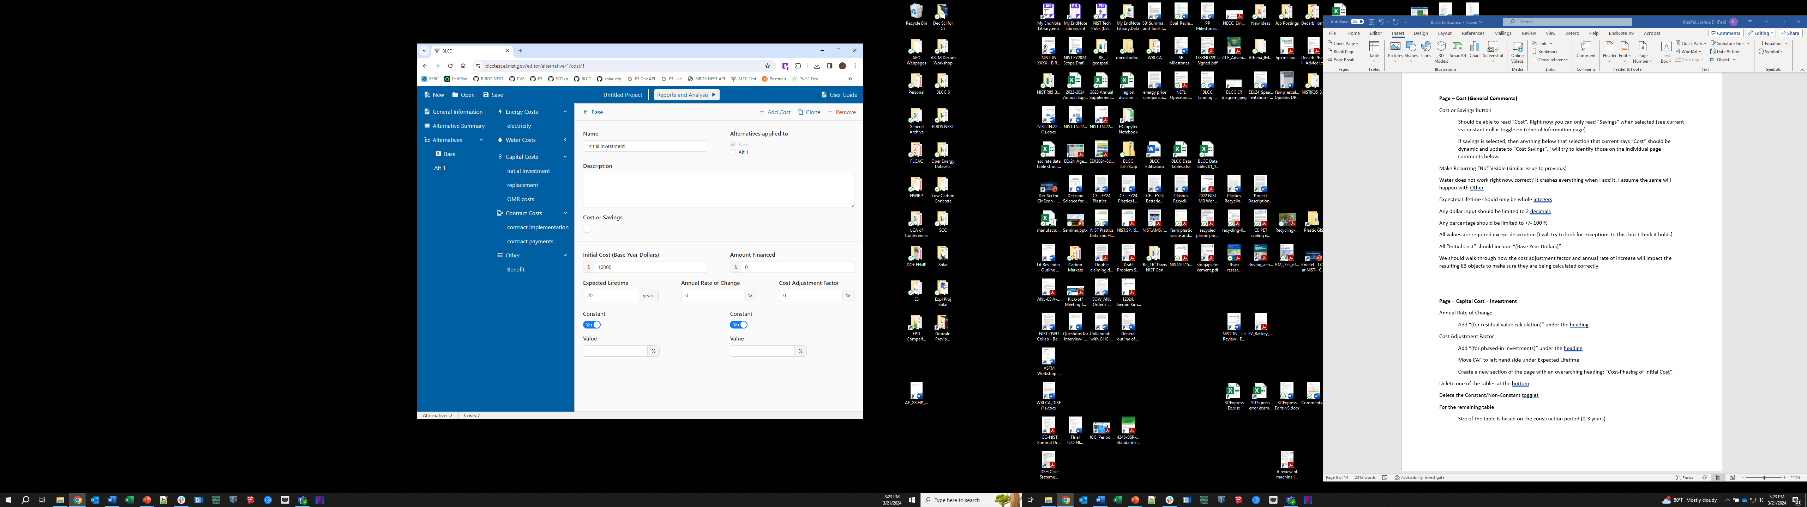

**Page – Capital Cost - Replacement**

Add “Initial Occurrence (from Base Year)”

Value is in years

This value is used with the construction phase to determine the initial year of occurrence

For the E3 object, you take the inputted value + construction phase value

Residual Value

“Percent” to “Percent of Initial Cost”

“Dollar” to “Dollars”

If savings selected in toggle

Initial Cost -> Initial Cost Savings

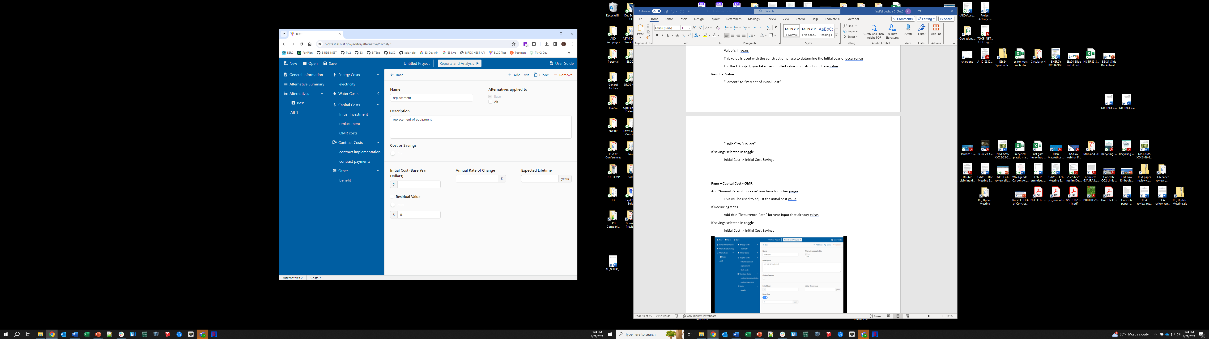

**Page – Capital Cost - OMR**

Add “Annual Rate of Increase” you have for other pages

This will be used to adjust the initial cost value

If Recurring = Yes

Add title “Recurrence Rate” for year input that already exists

If savings selected in toggle

Initial Cost -> Initial Cost Savings

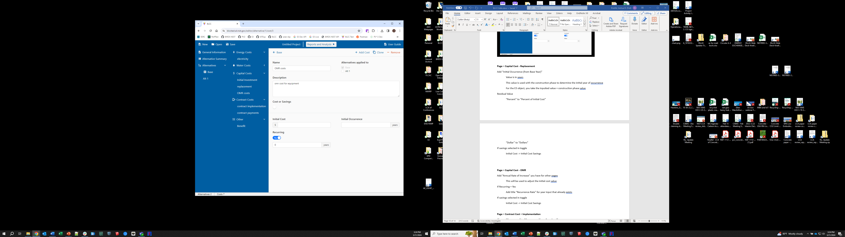

**Page – Contract Cost – Implementation**

Change “Occurrence” to “Occurrence (From Base Year)”

Change “Costs” to “Cost (Base Year Dollars)”

Add “Annual Rate of Increase”

Replicate from another page

If savings selected in toggle

Cost -> Cost Savings

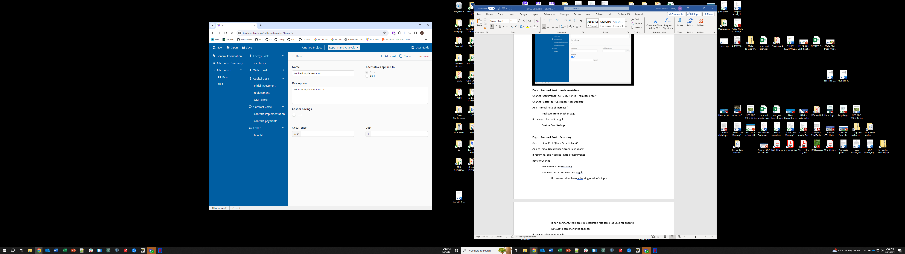

**Page – Contract Cost – Recurring**

Add to Initial Cost “(Base Year Dollars)”

Add to Initial Occurrence “(from Base Year)”

If recurring, add heading “Rate of Recurrence”

Rate of Change

Move to next to recurring

Add constant / non-constant toggle

If constant, then have a the single value % input

If non-constant, then provide escalation rate table (as used for energy)

Default to zeros for price changes

If savings selected in toggle

Initial Cost -> Initial Cost Savings

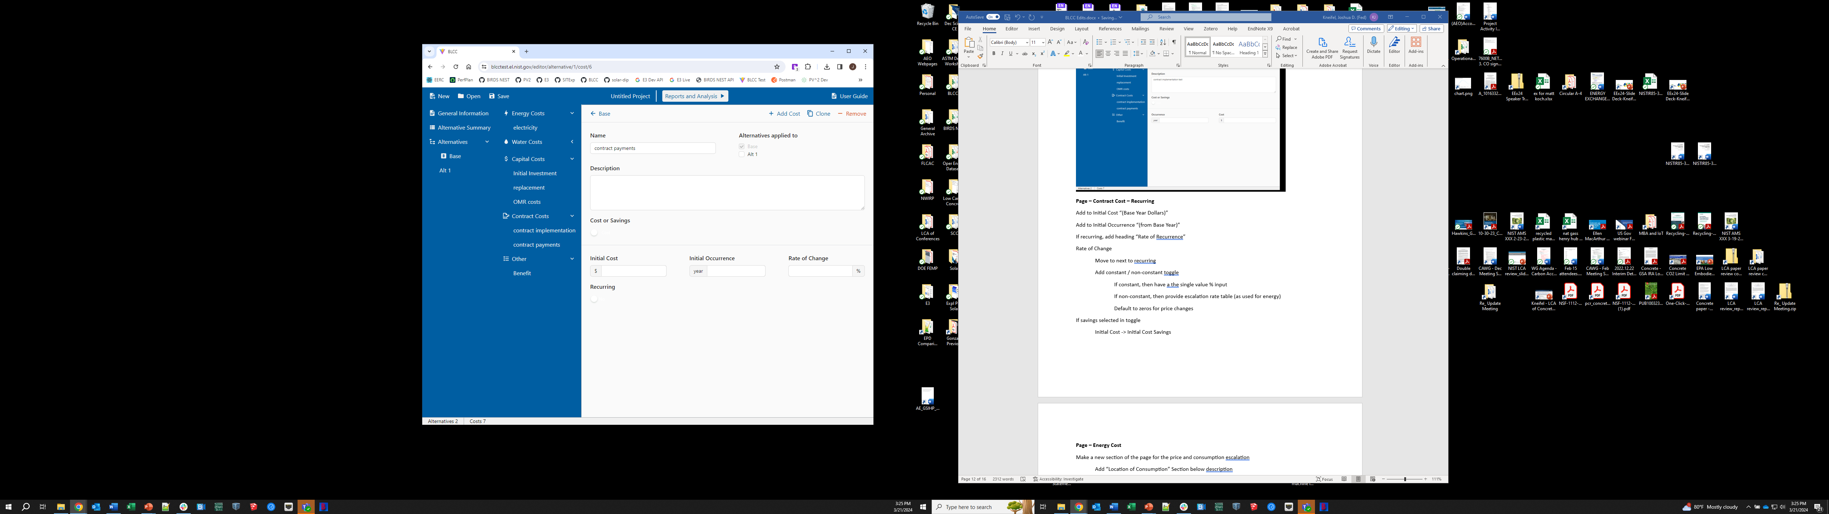

**Page – Energy Cost**

Make a new section of the page for the price and consumption escalation

Add “Location of Consumption” Section below description

Default to selection from General Information page

Country, State, City, ZIP [only zip is required]

Allow for changing selection

If US

State/Territory – searchable drop down

ZIP – drop down list based on State

If Not US

Default to US Average data

Cost Escalation

Add label for the escalation rate table: “Annual Price Escalation Rate”

Change heading “Value” to to “Escalation Rate” and keep there whether it’s a single value or a table of values

Change “Usage Index” to “Escalation Rate”

Input should be labeled %

Range can start with +/- 100. Most will be +/- 10 since they are percent changes

If not constant,

Create table for the length of the service period (study period – construction period)

Default to the data for the specific location-fuel type-customer type

Usage Index

Add label for the usage index table: “Usage Index”

No unit to display since its an index and not a percent

Expect this value to be around 1.00 most of the time. Although there are edge cases.

Max value of 10 [just to ensure its not mistaken to be an annual value and in %]

If not constant,

Create table for the length of the service period (study period – construction period)

Default to 1.00 for all Usage Indexes

Cost per unit does not default but the consumption unit does

Rebate can be defaulted to $0

Missing the Demand Charge

$ Annual

Default to $0

If savings selected in toggle

Cost Per Unit -> Cost Savings Per Unit

Demand Charge -> Demand Charge Savings

Two type of fuel oil

Distillate

Energy content assumption =

Residual

Energy content assumption =

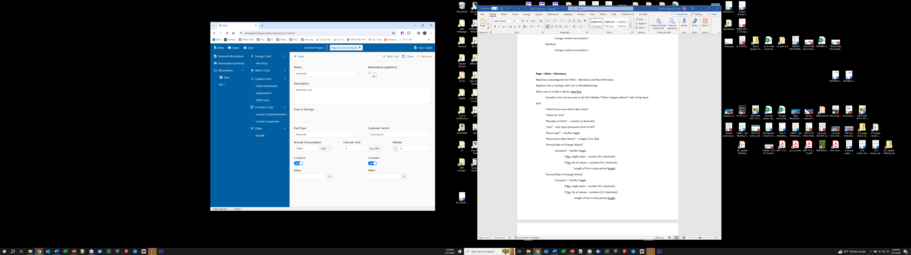

**Page – Other – Monetary**

Need two subcategories for Other – Monetary and Non-Monetary

Replace Cost or Savings with Cost or Benefit/Savings

Add a way to create a tag for reporting

Question: How do we want to do this? Maybe “Other Category Name” with string input

Add

“Initial Occurrence (from Base Year)”

“Value Per Unit”

“Number of Units” – number (2 decimals)

“Unit” – text input (character limit of 10?)

“Recurring?” – Yes/No Toggle

“Recurrence Rate (Years)” – integer (1 to 100)

“Annual Rate of Change (Value)”

Constant? – Yes/No Toggle

If No, single value – number (% 2 decimals)

If Yes, list of values – numbers (% 2 decimals)

Length of list is study period length

“Annual Rate of Change (Units)”

Constant? – Yes/No Toggle

If No, single value – number (% 2 decimals)

If Yes, list of values – numbers (% 2 decimals)

Length of list is study period length

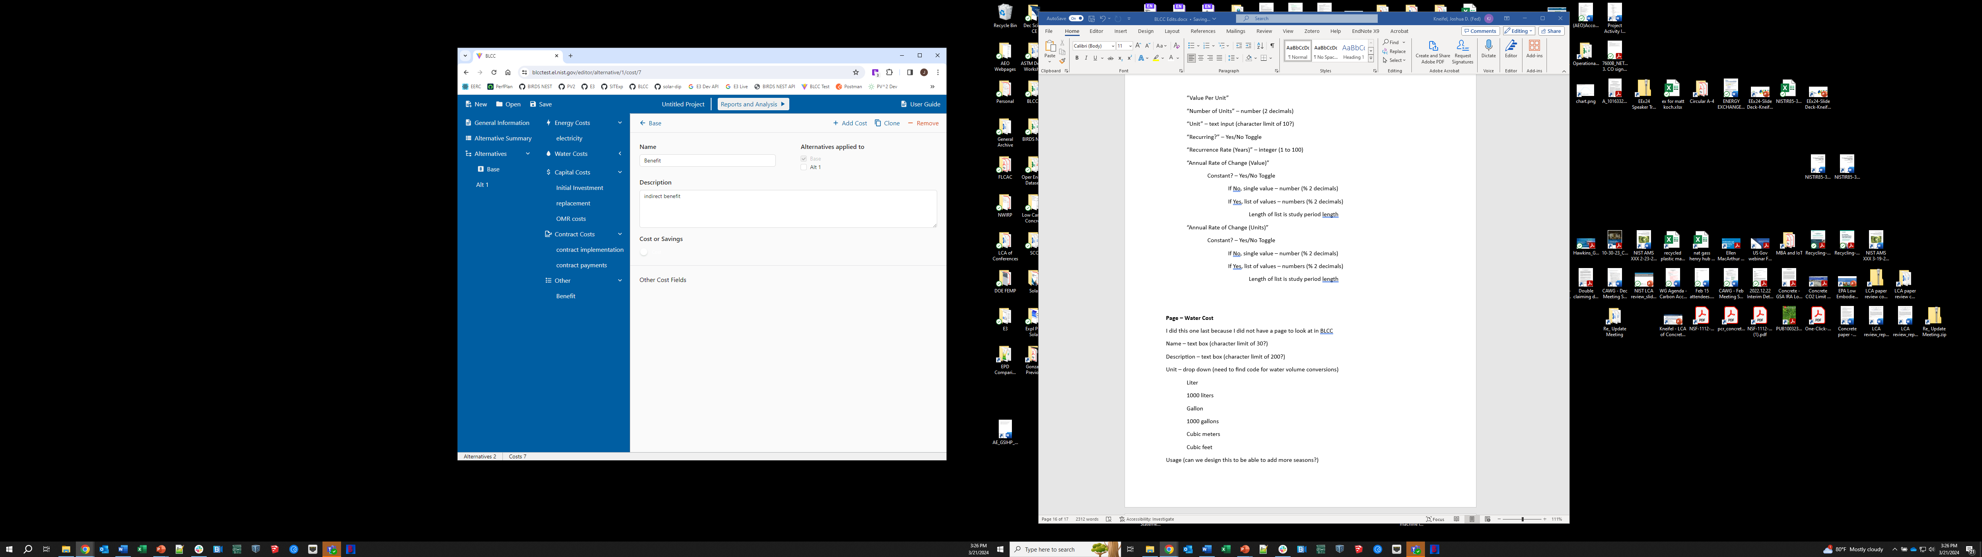

**Page – Water Cost**

I did this one last because I did not have a page to look at in BLCC

If I create a water cost, it shows up in the alternative summary, but errors out when I try to click on it.

This is the same information I provided in the original page details.

Name – text box (character limit of 30?)

Description – text box (character limit of 200?)

Unit – drop down (need to find code for water volume conversions)

Liter

1000 liters

Gallon

1000 gallons

Cubic meters

Cubic feet

Usage (can we design this to be able to add more seasons?)

Season 1 (Summer)

Cost Per Unit – dollar number (2 decimals)

Season 2 (Winter)

Cost Per Unit - dollar number (2 decimals)

Disposal (BLCC 5.3 has 2 seasons – summer and winter - design this to be able to add more seasons?)

Season 1 (Summer)

Cost Per Unit - dollar number (2 decimals)

Season 2 (Winter)

Cost Per Unit - dollar number (2 decimals)

Price Escalation Rate (generically this is Rate of Change - Value)

Constant? – Yes/No Toggle

If Yes

Single Constant Value – number (% 2 decimals)

If No

Annual Value – List – number (% 2 decimals)

List is the length of the study period

Use Index (generically this is Rate of Change - Units)

Constant? – Yes/No Toggle

If Yes

Single Constant Value – number (% 2 decimals)

If No

Annual Value – List – number (% 2 decimals)

List is the length of the study period